JORIS SMEETS LAUNCHES BOOK ON THE CORDILLERA

Joris Smeets is a solidarity friend of the Cordillera Peoples Alliance. He went on internship in the Cordillera region in 2006 with the CPA. In his book he writes about his experience, insights, and friendship with the Cordillera peoples and Rafael Markus “Makoy” Bangit, CPA Elders Desk Regional Coordinator and member of the CPA Regional Council at the time of his death. Makoy was politically assassinated in June 8, 2006 in Isabela. Smeets is also a member of CPA Friends Abroad.

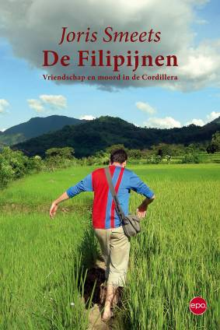
In his book "The Philippines: Friendship and Murder in the Cordillera" Joris Smeets describes the tragic story of Makoy, one of the leaders of a local people's movement, against the background of hundreds of disappearances and killings on the Philippine islands.

In the company of a Filipino friend the young Joris Smeets travels to the Philippines. This journey took him to beautiful beaches and hospitable villages. He could however not avoid noticing the poverty and blatant inequalities. Three years later, he returns to become a volunteer in the Cordillera, a mountainous region in the northern part of Luzon.
Through the Cordillera People's Alliance (CPA) he becomes acquainted with the Igorot, the indigenous people of the Cordillera. He befriends Makoy, a CPA leader. Makoy shows Joris life as it is in his home province Kalinga. Thanks to CPA he learns all about the contrasts in Philippine society and realizes that activists are being systamatically murdered.

Only a few weeks after he returns to Antwerp, Belgium, Joris learns Makoy was shot in front of his son. Joris decides to head back to the Cordillera. #

