May 23, 2009

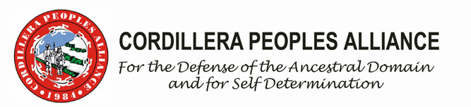
CPA Attends Eighth Session of the UN Permanent Forum on Indigenous Issues

The Cordillera Peoples Alliance joins indigenous peoples around the world on the Eighth Session of the United Nations Permanent Forum on Indigenous Issues which started on May 18 at the UN Headquarters, New York, USA. The Eighth Session’s Agenda includes the implementation of the UN Declaration on the Rights of Indigenous Peoples. CPA Vice Chairperson for External Affairs Jill Cariño and CPA Secretary General Windel, from the Ibaloi and Bontok-Kankanaey peoples of the Cordillera, respectively,are currently attending the Session.

The Cordillera representatives through CPA have submitted recently the Cordillera Statement on Agenda No. 3a, which is on Economic and Social Development.

“In spite of the widespread nationwide opposition to large scale mining, the Philippine government under President Gloria Macapagal-Arroyo has aggressively liberalized the mining industry to attract foreign mining investments. It issued policies, such as the National Minerals Policy and Mineral Action Plan, to accelerate the implementation of the Philippine Mining Act of 1995 resulting in the rapacious plunder of ancestral lands and destruction of the environment of indigenous peoples,” the statement reads.

The CPA recommended for a moratorium on large-scale mining and extractive industries in indigenous territories until mechanisms addressing outstanding issues are set, especially on compensation and rehabilitation of devastated communities and the urgent concern on climate change; and that projects affecting indigenous peoples can only be undertaken within the framework of the United Nations Declaration on the Rights of Indigenous Peoples, especially the recognition of our right to our land and resources; free, prior and informed consent; transparency and accountability of companies and investors.

CPA also called for the review and repeal of laws, such as the Philippine Mining Act of 1995, to be consistent with the United Nations Declaration on the Rights of Indigenous Peoples and reforming the industry, and the demilitarization of communities threatened and affected by mining projects and investments and stop political persecution of environmental and indigenous activists.

The CPA supported other interventions made during the first week of the Eighth Session, inlcuding the intervention on Item 6, which is the Asia Indigenous Caucus Statement to the Food and Agriculture Organization (FAO). The Asia Indigenous Caucus on Agenda 3a (Economic and Social Development was presented by CPA. #

Cordillera Peoples Alliance Public Information Commission (CPA-PIC)
Email: pic@cpaphils.org
Website: www.cpaphils.org
P.O. Box 975
No. 55 Ferguson Road, Baguio City
Philippines 2600
Telephone Number (063) (74) 304-4239
Fax: (063) (74) 443-7159

