

Republic of the Philippines
Province of Ifugao
Office of the Provincial Governor

STATEMENT FOR THE SURFACE JAMES BALAO CAMPAIGN


Yet another son of the Cordilleras, another activist for our rights, has disappeared.
I don’t know James Balao personally. But I know his kind. There are only a few of us who have the courage to devote one’s life to pursuing difficult causes. Yet he craves no praise or gratification. Just a desire that the coming generations of Cordillerans will live in a region of genuine peace, sustainable development and self-determination.
Thus, I join all those who have manifested their indignation over his disappearance. I condemn forces of political intolerance and brute force who have sought to silence Balao’s crusades with an act of terror.
For whatever ideology, political belief or religious persuasion that propels our actions, the value of non-violence and human rights must be upheld.
True, we live in a world of conflict, a war of attrition. But Cordillerans have for centuries resolved their conflicts respecting the rule of traditional law and human rights. The casualties of our wars were slain in acts of honor, not with treachery. The battles waged by our forefathers were for freedom, not for fascism.
These were the things James fought for. Despite the fears and the solitude, he struggled. We owe him this much to pray and demand that he be returned to the family and community he so loved.
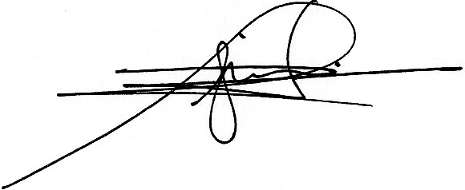

TEODORO B. BAGUILAT, JR.
Provincial Governor

