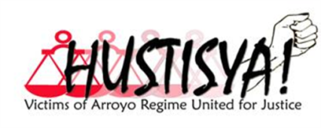Northern Luzon
PRESS RELEASE
FAMILIES OF HUSTISYA-NL DEMAND RESOLUTE ACTION FROM PRESIDENT NOYNOY AQUINO ON HUMAN RIGHTS VIOLATIONS
Victims of human rights violations under the organization of HUSTISYA-Northern Luzon urge President Benigno C. Aquino III to exhaust all means necessary to help victims of human rights violations attain justice.
This June, Hustisya-NL shall commemorate the 5th death anniversary of tribal elder-leader Rafael Markus Bangit who was killed on June 8, 2006. Bangit was the Vice-Chairperson of Bayan Muna Kalinga; the regional coordinator of the Cordillera Peoples Alliance (CPA) elder’s desk and the Binodngan Pongors Organization. His wife Agustina is now trying to make ends meet to sustain the needs of their four (4) children.
This same month, HUSTISYA-NL shall commemorate the 1,000 days of James Moy Balao’s enforced disappearance which will fall exactly on June 12, 2011. James is a founding member of the CPA. State security forces abducted him on September 17, 2008 at La Trinidad, Benguet. James has not been brought back to his family and colleagues. His parents, Arthur and Jane Balao passed away last year without seeing their son.
HUSTISYA families condemn all the political killings, enforced disappearances and various forms of human rights violations. We are mostly grieving women and children, coping up with the loss of our husband/parent/sibling/family member. However, this would not limit us to continue with the call for justice.
We ask the President to heed our calls. Prosecute the perpetrators of human rights violations and make the past bloody administration of GloriaMacapagal-Arroyo accountable. We further call to stop the continuing cases of extrajudicial killings, enforced disappearances and other human rights violations under the new Operation Plan Bayanihan. In fact, we do not see any significant development in terms of the human rights situation in the country. We do not see an end to this violence.
While the violations continue, we amplify our call. We demand no less than justice!
Justice for Markus Bangit! Justice to all Victims of Political Killings!
Surface James Balao! Surface all the Disappeared!

June 8, 2011

For Reference: HUSTISYA-NL Council of Leaders Representatives
Agustina Bangit; 09089650262 (for phone patch interview)
Joni Balao-Struggar; 09202804315
Florence Dayasen; 09283901430

